

PE-xxxx  
Revision A

WS1050 MEMS CYCLING AND HOLD DOWN

TEST PROCEDURE

Table of Contents

1. Purpose and Scope 3

1.1 Purpose 3

1.2 Scope 3

2. Responsibilities 3

3. REFERENCE DOCUMENTS 3

4. FORMS 3

5. DEFINITIONS (Not Applicable) 3

6. EQUIPMENT AND MATERIALS 4

7. REQUIREMENTS AND PROCEDURES 4

7.1 Basic Hardware, Software, and Environmental Requirements 4

7.2 MEMS Cycling 5

7.3 MEMS Hold Down 5

7.4 Reject Criteria 5

7.5 General Set-up and Handling Guidelines 5

7.6 Test Set-up Procedure 6

7.7 Test Operating Procedure 8

8. REVISION HISTORY 15

# Purpose and Scope

## Purpose

This document defines the procedures and requirements for cycling and continuous hold down stresses for MEMS tunable capacitors.

## Scope

This procedure applies to the qualification and ongoing production monitoring of WS1050.

# Responsibilities

The Product Engineering function is responsible for assuring compliance to the requirements of this document.

# REFERENCE DOCUMENTS

|  |  |
| --- | --- |
| Document No. | Document Name |
| PE-0002 | Equipment Calibration Procedure |

Table 1 Reference Document List

# FORMS

|  |  |
| --- | --- |
| Form No. | Form Name |
|  |  |

Table 2 Form List

# DEFINITIONS (Not Applicable)

# EQUIPMENT AND MATERIALS

Equipment consists of:

|  |  |  |  |
| --- | --- | --- | --- |
| **Item** | **Model** | **Manufacturer** | **Comments** |
| Computer (equipment controller) | PC with Window XP, 7 | Any |  |
| Software (equipment controller) | LabView 2012 or Higher |  |  |
| GPIB-USB-HS | 778927-01 | National Instruments |  |
| Triple Output Power Supply | E3631A | Agilent/Keysight | w/ GBIP interface |
| Source Meter | 2400 | Keithley | w/ GBIP interface |
| DMM | 2000 | Keithley | w/GPIB interface |
| FPGA | PIX-7813R | National Instruments |  |
| PXI Card Chassis | PIX-1033 | National Instruments |  |
| DUT boards | Various**1** | --- | WiSpry Design |
| SHC68-68-RDIO Shielded Cable | 191667-01 | National Instruments | NI Cables |

Table 3 MEMS Reliability Stress Stand Equipment List

Notes:

**1** WS1050 board is 36 positions (model WS-EVB-165)

# REQUIREMENTS AND PROCEDURES

## Basic Hardware, Software, and Environmental Requirements

* Cycling and hold down hardware (boards, cables, connectors, bench equipment) must be able to:
  + Meet the electrical conditions specified in sections 7.2 and 7.3.
  + Meet WiSpry calibration requirements specified in PE-0002.
  + Be sufficiently robust to ensure minimum leakage currents.
* Cycling and hold down software should:
  + Allow for insitu monitoring for stiction events.
  + Meet the electrical conditions specified in sections 7.2 and 7.3.
* Cycling and hold down environmental controls shall:
  + Provide control of temperature and humidity.
  + Meet calibration requirements defined in PE-0002.

## MEMS Switch Cycling Stress

The cycling conditions for product qualification and ongoing monitoring are:

|  |  |
| --- | --- |
| **Stress Condition** | **Requirement** |
| MEMS Operating Voltage (VOP) | 44 V |
| VDD | 3.7 V @ 12 KHz |
| Temperature | 65 oC |
| Frequency | 12 KHz |
| Duty Cycle | 25% |
| Dual Voltage Actuation (DVA) | OFF |
| Beam Actuation | All beams cycles simultaneously |
| Beam Read Points | 1k, 2k, etc. |
| Bank Read Points | Serial: 1, 2, then 3? |

## Table 4 MEMS Switch Cycling Stress Conditions for product qualification.MEMS Continuous Hold Down Stress

The continuous hold down conditions for product qualification and ongoing monitoring are:

|  |  |
| --- | --- |
| **Stress Condition** | **Requirement** |
| MEMS Operating Voltage (VOP) | 44 V |
| VDD | 3.3 V |
| Temperature | 65 oC |
| Frequency | ---- |
| Duty Cycle | 100% |
| Dual Voltage Actuation (DVA) | OFF |
| Beam Actuation | All beams cycles simultaneously and held for the stress duration |
| Beam Read Points | 15m, 30m, 45m, 60m, 2h, 3h, 4h, …..(?) |
| Bank Read Points | Serial: 1, 2, then 3? |

Table 5 MEMS Continuous Hold Down Stress Conditions for product qualification.

## Reject Criteria

For both cycling and hold down, the following conditions define a reject reading:

COFF ±46 fF per bank

CON ±657 fF per bank

## General Set-up and Handling Guidelines

* Handling recommendations for ESD
* Stabilize oven temperature prior to loading parts, 15 minutes minimum
* Preconditioning of new stress boards (to remove excess absorbed moisture), 24 hour bake at 85°C
* Optimal method to load boards
* Special software instructions
* Best way to unload parts
* Socket inspection after each run and cleaning/repair as required
* Sample control and storage post stress

## Test Set-up Procedure

* Figure 1 shows the test set-up block diagram for WS1050 Reliability Test, Multi DUT.
* Using banana plug cables to connect all test equipments as in Figure 1.
* For power supply E3631A, use channel 1 for VDD, channel 2 for +3.3V.



Figure 1 MEMS Cycling and Hold Down Reliability Stress Test Set-Up Block Diagram

* Figure 2 shows the front panel of the test program (for the WS1050 version 1.4)
* Contact WiSpry Engineering for the latest version of the test program.
* Test programs are located in directory S:\Software_Control\Released\36 DUT Board

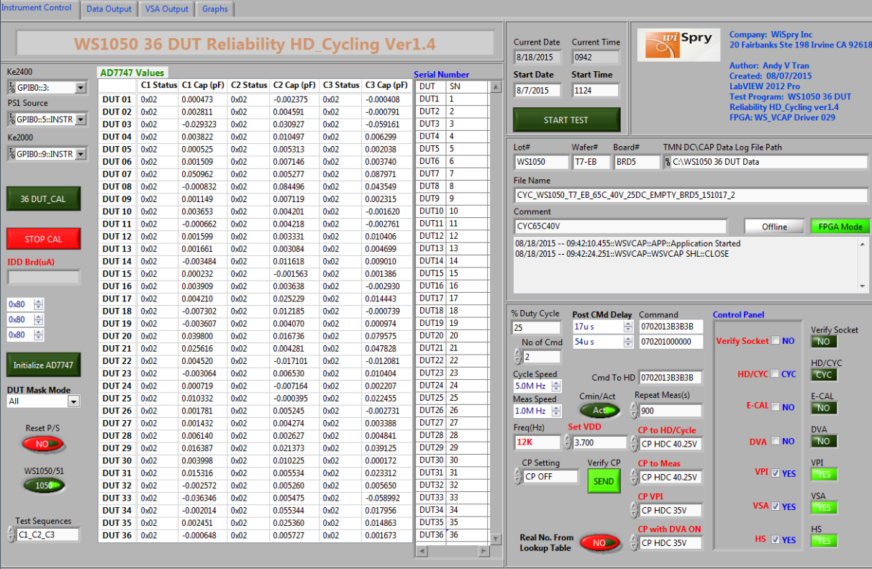

Figure 2 Front Panel of the WS1050 36 DUT Stress Test Program

## Test Operating Procedure

* Set Oven/Chamber Temperature
* Set oven/chamber temperature to meet requirement (e.g.25°C, 45°C, 65°C)
* Set-up test program
* From labVIEW test program click  this button at the top left corner to run the test program, it will pop-up a dialog box (Figure 3) below to ask the look up table for read point

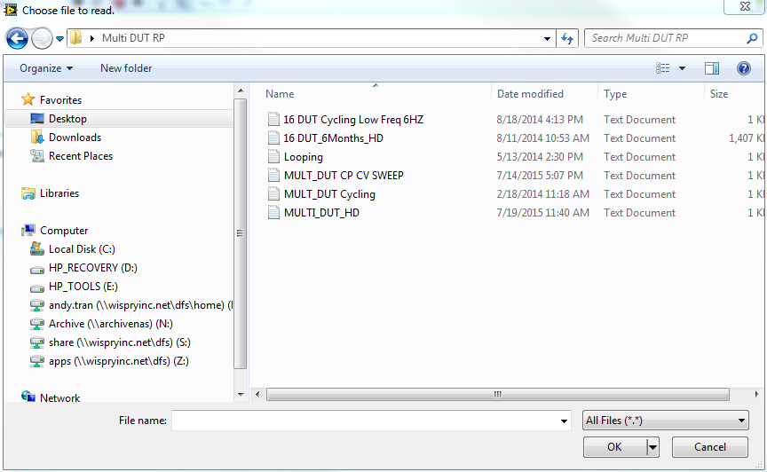

Figure 3 Share Drive Folder for Multi-DUT Cycling or HD Read Point Definition

* Select the correct Read Point file depending on the stress being run;
  + Select **MULT_DUT Cycling** for cycling test
  + Select **MULT_DUT HD** for hold down test
* For calibration (Figure 4): Make sure all sockets are empty and the capacitance values of 36 DUT are around zeros “~0” for all three banks. If not, click on 36 DUT_CAL button  to zero out the sockets, then click STOP CAL button  to stop the calibration.

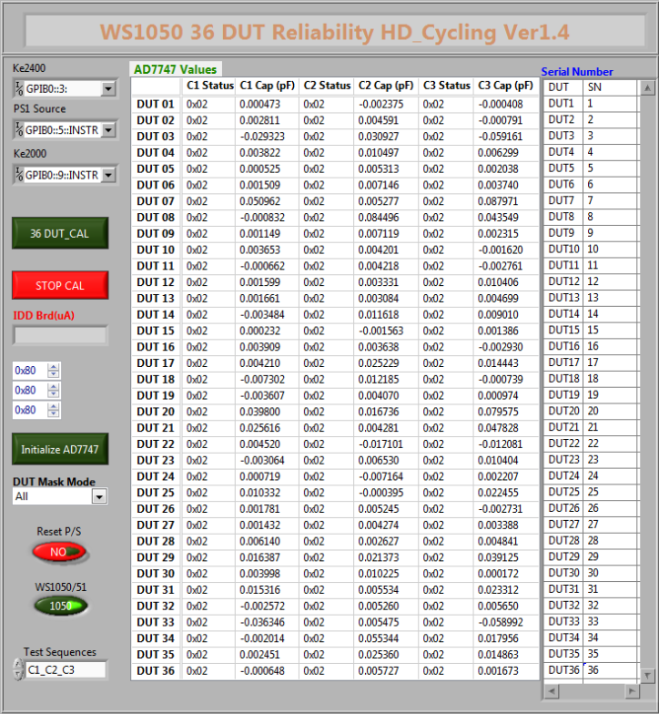

Figure 4 Empty Socket Calibration Summary Window

Note: If sockets are not zeros “~0”, click on initialize AD7747 button  to initialize the ADI chip, make sure the capacitance values will be less than 1pF (<1pF) for all three banks of 36 DUT, click on 36 DUT_CAL button to zero out the sockets then click on STOP CAL button to stop the calibration.

* Set-up test condition (Fig. 5): The front panel below was set by default with cycling, DVA OFF, E-CAL OFF, VPI ON, VSA ON, HS (hand shake check) = ON, VDD = 3.7V, cycle frequency = 12 KHz, CP stress = 40.25V, CP VPI = 35V.

# 

Figure 5 **Test Condition Set-Up Front Panel for default cycling conditions (DVA=OFF, ECAL=OFF, VPI=ON, HS (Handshake)=ON, Duty Cycle=25%,VDD=3.7V, Frequency = 12KHz, CP=40.25V, CP VPI=35V.**

* Set-up with standard stress (cycle): All Drivers ON, All Drivers OFF, 25% Duty. All numbers should be set as same as the boxes are shown below**:**

# 

Figure 6 All Drivers ON and All Drivers OFF Set Up Box for 25% Duty Cycle. The numbers in the Command box should be represented as shown.

* Set-up with special stress (cycle): C1 ON, C2 OFF, C3 OFF; C1 OFF, C2 ON, C3 OFF; C1 OFF, C2 OFF, C3 ON, 33% Duty. Make sure all the numbers will be set as same as the boxes are shown below:

# 

Figure 7 Special Cycling Stress Test Set-Up with 33% duty cycle. Note: Commands numbers must be as shown in the Figure.

* + Set-up for stress (Hold Down): All Drivers should be closed during hold down, 100% duty, this was set by default



Figure 8 Stress Test Control Set Up for Continuous Hold Down. Note: Commands numbers must be as shown in the Figure.

* Figure 9 shows the front panel is set-up to collect the test data.

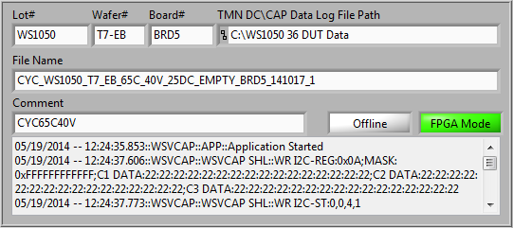

Figure 9 Front Panel to Set-Up Data Collection

Note: The file name format will be…

**stress_lot#_wafer#_design_temperature_CPV Stress_duty_brd#_yymmdd_run**

* The test can be set to start immediately by clicking on the START TEST button; alternatively the start date and time can be programmed as shown in Figure 7.

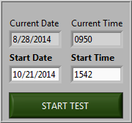

Figure 10 Cycling or Hold Down Stress Initiation for immediate or delayed start.

**Note:** **The time shall be set at least 30 minutes to wait after loading parts to the board in the oven/chamber. This time is required for the stabilization of the board dwell time at the temperature before to run stress.**

* The front panel (Figure 11) displays the capacitance values for every read point.

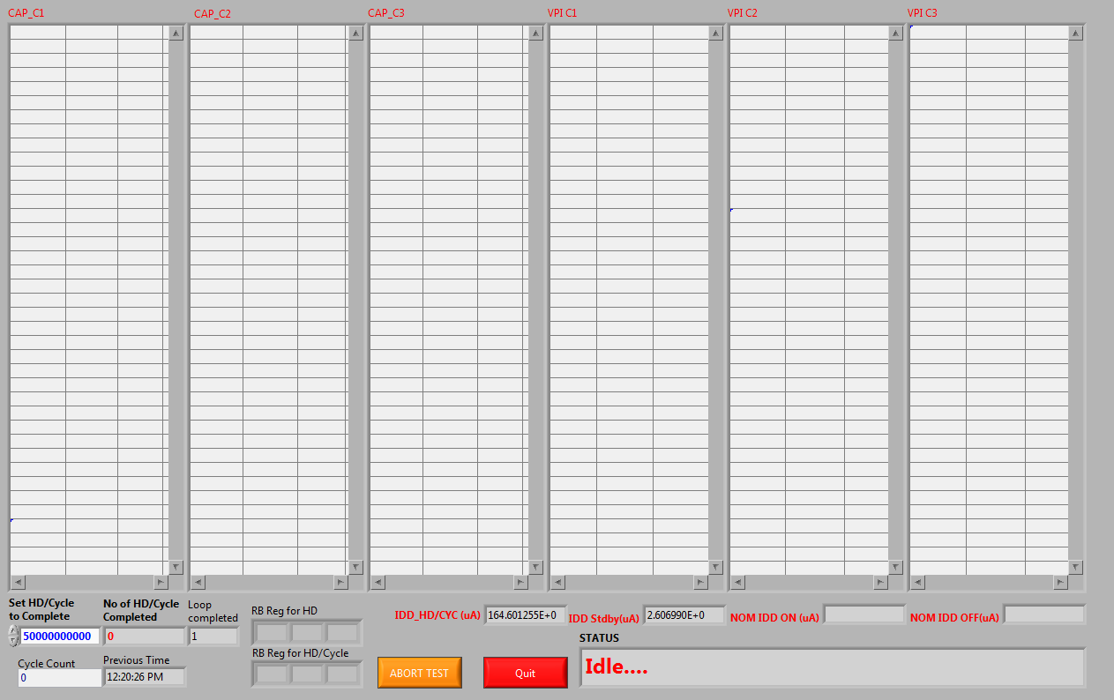

Figure 11 This Front Panel will display the capacitance values at every read point.

* The front panel (Figure 12) displays VSA, HS check, EFUSE, % Delta CAP for every read point

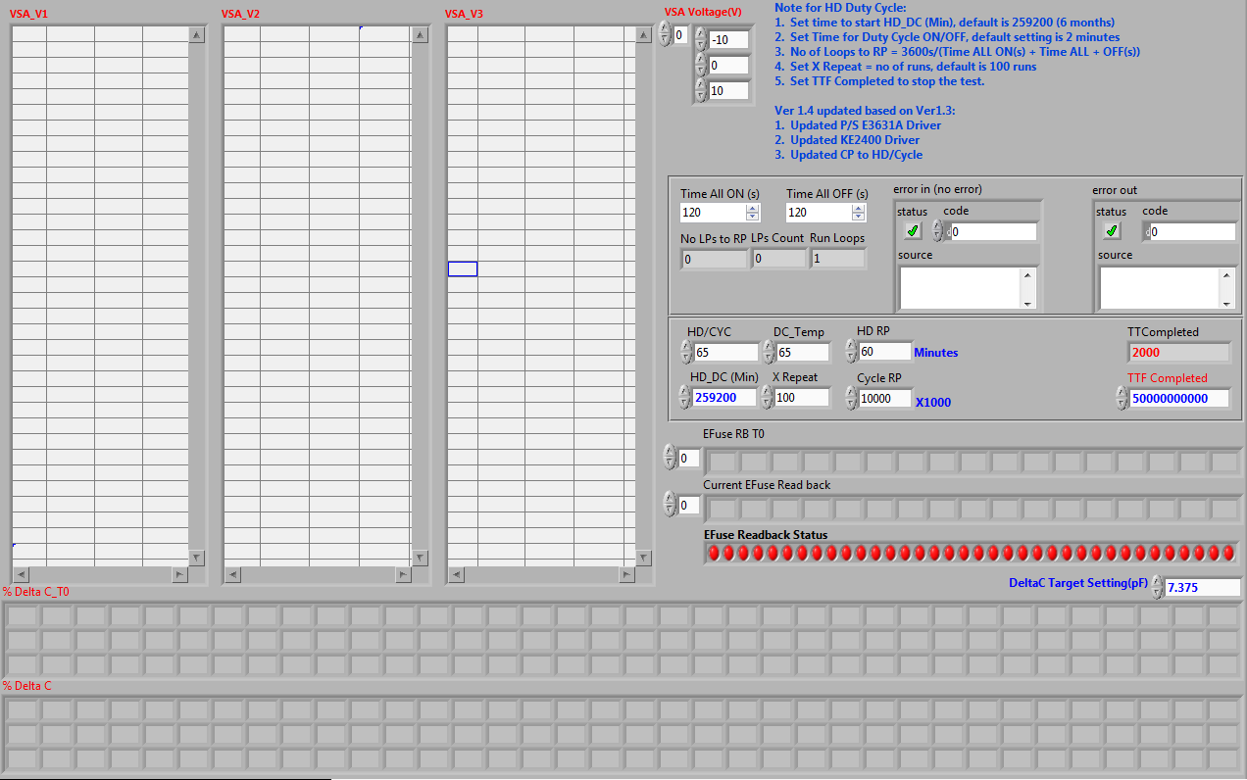

Figure 12 The Front Panel shown will display the VSA, HS check, EFUSE, %DeltaCAP for every read point.

* Figure 13 shows the output results, so that changes in CMIN can be monitored during stress.

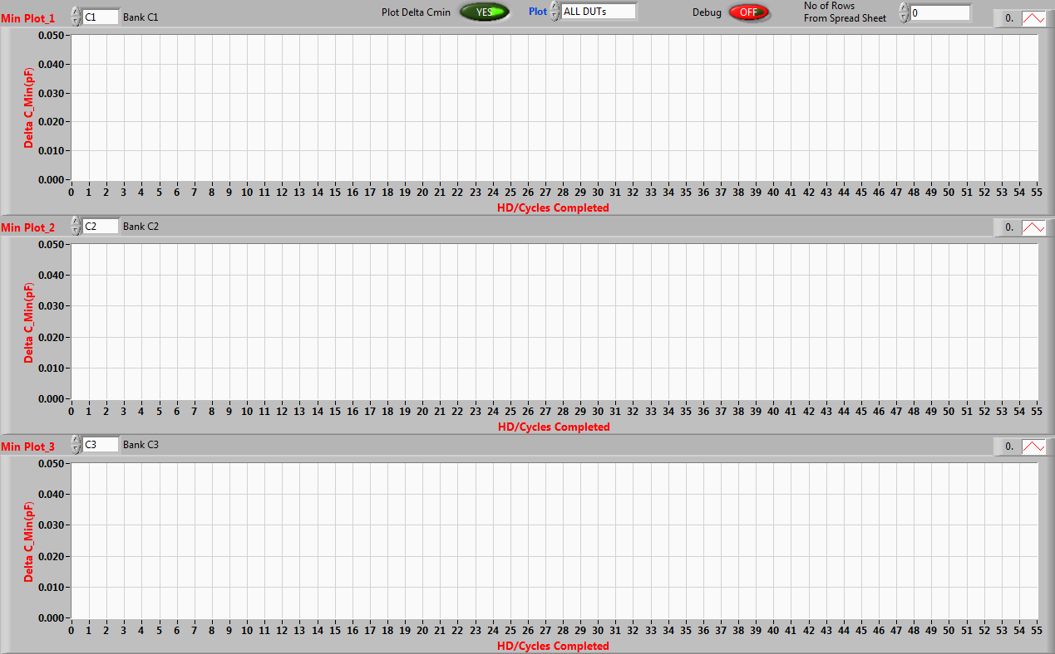

Figure 13 This shows the Output results for monitoring the instantaneous changes in Cmin

* Stop stress or abort the test: The test can be aborted immediately by click on the ABORT TEST button (Figure 14) or enter the number that will be set to complete the test (5 billion cycles is set by default).

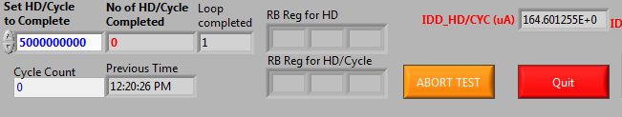

Figure 14 This panel can be used to ABORT the stress or to set the minimum number of cycles to achieve. The button ABORT TEST will abort the stress.

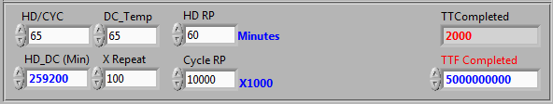

Figure 15

# REVISION HISTORY

|  |  |  |  |
| --- | --- | --- | --- |
| Rev | Description | Editor | Date |
| A | Initial Release | M. Johnson | 12-Aug 2015 |